The below screenshots are the outputs for each steps of the code for Assignment 5.

Step 1:

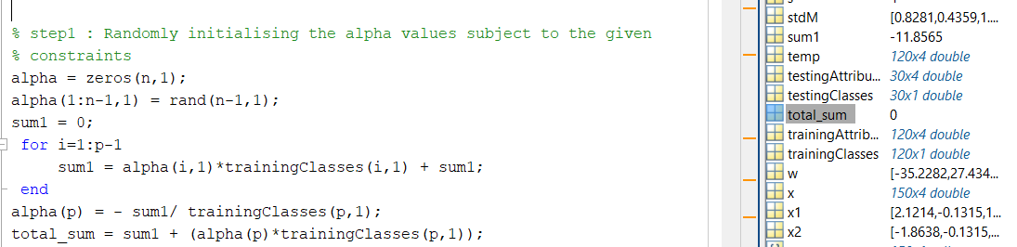

Step 2:

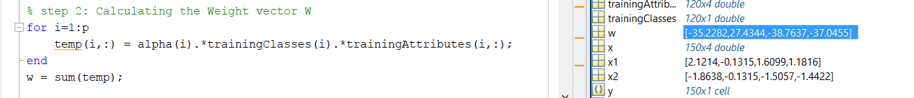

Step 3:

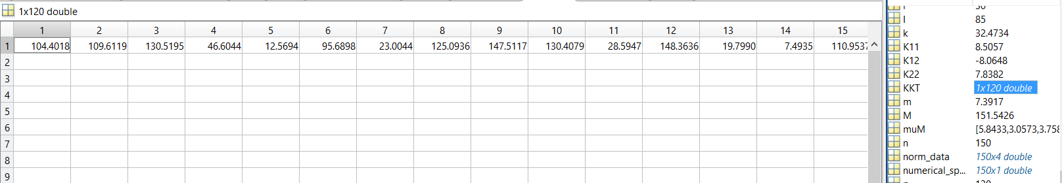

Step 4:

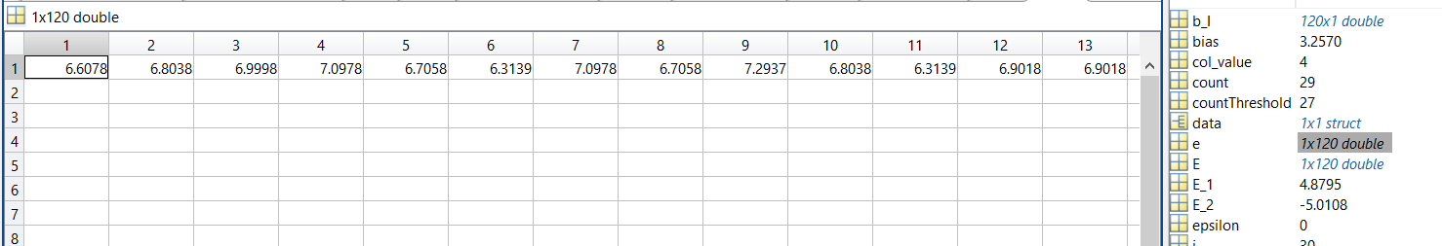

Step 5:

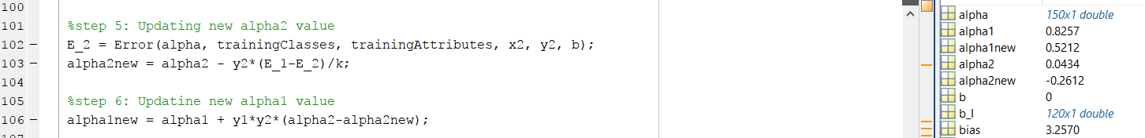

Step 6:



Step 7:

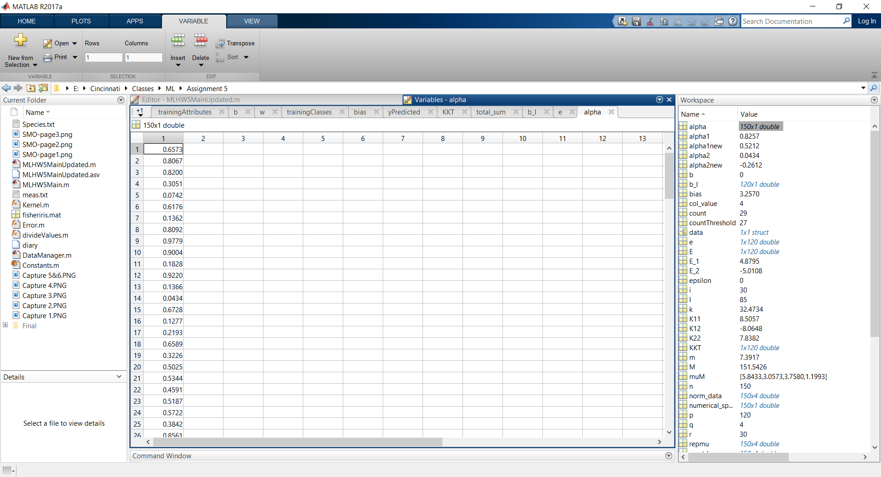

Step 8:

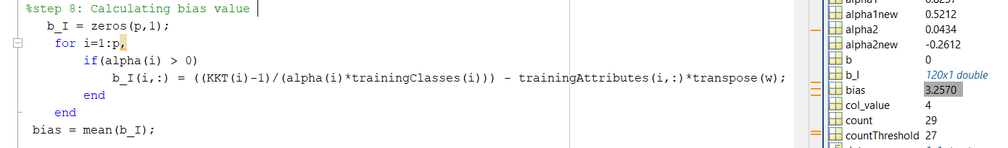

Step 9:

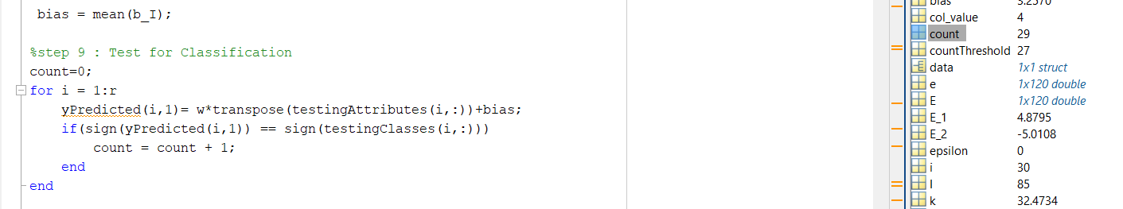

Y-Predicted:

